# INTRODUCTION

This Software Requirements Specification provides a complete description of all the functions and specifications of the Go-Dev Know Africa education game. The game is intended for either entertainment or educational purposes. The expected audience of this application are users who want to test their knowledge of Africa, as well as users who want to learn about geographical locations and famous African heroes.

# PURPOSE

To create an application capable of testing a user's knowledge on African countries and its iconic heroes. This can be used as an educational tool, which is capable of expanding a user’s knowledge through, quizzical methods. The proposed system will have the following merits outlined below:

● Allows user full functionality and freedom.

● System is user friendly, functionality is well defined.

● System is educational.

● System provides quick response time.

● System will be clear and sensitive to user needs.

# PRODUCT SCOPE

To function as an educational tool, which uses geographical based questions through an interactive interface. The interface will have a clean and have high usability with quick response time. Input must provide a clear response as to whether the answer is correct or incorrect. The application will challenge the user’s knowledge of both African countries and its associated African Heroes. The user must answer a specified number of questions to proceed to level two. Level one is geographical questions and level two is African hero based questions. There will be a fail state, which is determined via a set time limit to answer the questions, as well as a limit on how many incorrect answers can be given.

# Functional Requirements

● The system must be able to provide help and instructions accurately on demand.

● The system must allow to exit at any point in time

● The system must be able to allow the user to check validity of answer provided

● The system must provide the ability to restart if requirements are not met and advance to the next level if requirements are met

**Quality**

The quality of the game is designed to be universal in its operation. For this reason, the graphics were simplified so that operability and response time will not be negatively affected on legacy systems. This is to cater for the maximum user base.

**Completeness**

There are no additional downloads required to operate this game, other than software stipulated in the Readme file. Additional content could be added to this game via additional questions and different levels of challenge (E.g. which country has the highest birth rate)

**Accuracy**

All the questions are accurately matched to their respective countries. Right and wrong decisions are marked accordingly.

**Appropriateness**

As stipulated in the "Purpose", the game has been designed for the target audience. Its simplified interface and ease of use, will mean that users who know nothing about geography will still be able to answer the questions, due to the striking map and clearly identified functions.

**Clarity**

User input/responses and system output/responses are clearly defined by the interface. All interaction with the application provides a unique visual response (e.g. clicking a wrong country provides a red message, informing the user of their incorrect decision)

# Application Overview

## Architecture

Refer to **Diagrams** and its included files for technical diagrams

## How to play

## The application is centered on African geography. User has an interface consisting of a map of Africa and three options:

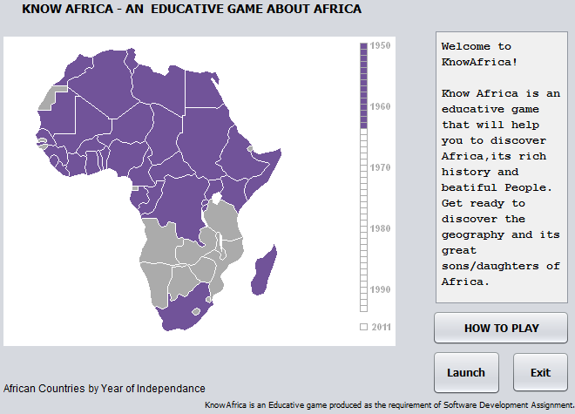

* "Launch": This starts the question game
* “HOW TO PLAY” provides a description window explaining how the game is played
* “Exit” ends the application process

**HELP**

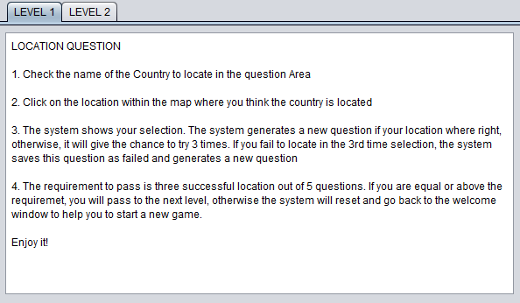

Click HELP for information on how to play the game

**Launch**

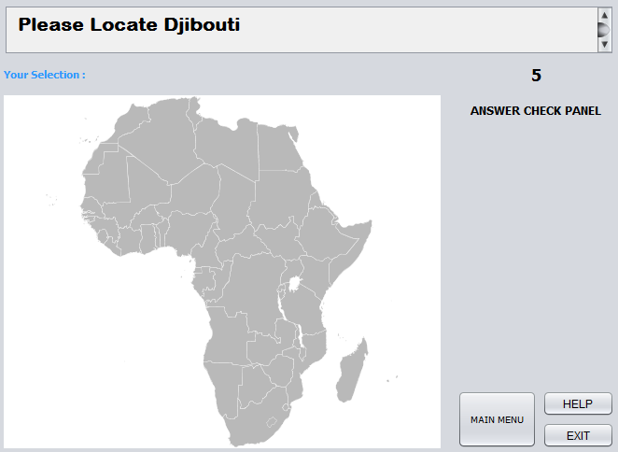

Clicking “Launch”, starts the game. The user must answer the question “Please Locate Djibouti”, by selecting a location on the map that is Djibouti. There is a 10 second count down timer to answer the question. User has 3 attempts to get the right answer

If the answer is wrong, then the question changes and the user gets a message informing them of their incorrect choice

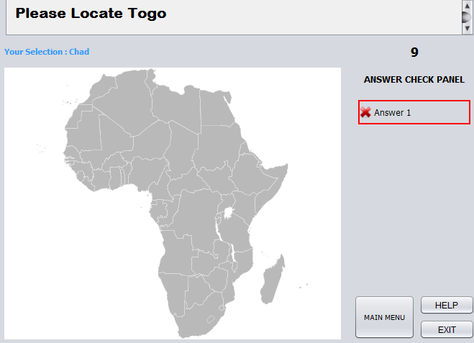

The user only gets 5 questions. The user needs to answer 3 out of 5 right to progress, otherwise they are sent back to the main menu.

**Level 2**

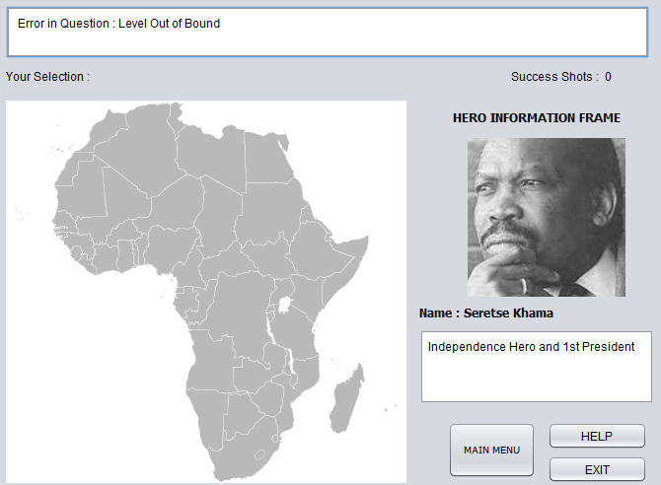

Level two has the same functionality as the first one but the questions have changed from locations, to Heros. User only has 1 attempt instead of 3.

**Winning**

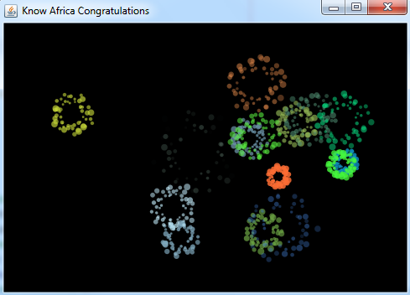

After answering 5 questions correctly, the user is presented with a celebratory screen with an accompaing sound file to amplify the excitement of winning.

# Buildability

Using Netbeans you can add a the godev-educativeGame repository from Github.com. Once cloned into Netbeans you can edit the included classes and files. The application is operable and editable through this method.

To be able to create an installalable project, refer to the third party software in the Readme

# Installability

Refer to the readme under install instructions

# Limitations

# Due to the installSimple software, the application requires you to have a Windows Operating System to install. Onlt has two levels and a limited selection of questions, so replayability is limited to those. Cannot work on mobile devices.

# Application Evolution

This application can evolove through additional levels added into the program. More complex questions with a diversity of countries involved will heighten the challenge. Cross platform operation would be a mandatory step in evolving this application.

# Work Break Down Structure

# C:\Users\211124974\Downloads\CPUT exams\WBS.png